**Analytics Project (MD Shoeb Akhter)**

**1.Item-wise order quantity**

1. **Which Items have been ordered most and which items have been ordered least?**

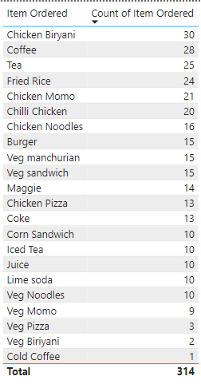

Most ordered items: Chicken Biryani, Coffee, Tea

Least ordered items: Veg Pizza, Veg Biriyani, Cold Coffee

1. **What will be your conclusion based on this?**

**Non-Veg Items:**

* **Top Seller:** Chicken Biryani is the most sold item overall and within non-veg items.
* **Comparison:** Non-veg items are sold more frequently compared to veg items.

**Veg Items:**

* **Top Seller:** Fried Rice is the most ordered item within veg meal options.
* **Comparison:** Veg items are ordered less frequently compared to non-veg items.

**Beverages:**

* **Top Sellers:**
  + Coffee with an order count of 28.
  + Tea with an order count of 25.
* **Least Popular:** Cold Coffee is the least favored beverage.

**Key Insights:**

* Chicken Biryani dominates sales, highlighting its popularity among customers.
* Fried Rice leads in the veg category, indicating a preference among veg meal options.
* Among beverages, traditional choices like Coffee and Tea are preferred, while Cold Coffee is the least popular.

**Recommendations:**

* **Increase Inventory:** Consider increasing inventory for Chicken Biryani and Fried Rice due to their high demand.
* **Promotions:** Run promotions or discounts on Cold Coffee to boost its sales.
* **Customer Feedback:** Gather feedback on Cold Coffee to understand the lack of interest and make necessary adjustments.

**2.Find out for which item more units are ordered in a single order.**

1. **Do we observe more units ordered against lower-priced items or higher-priced items?**

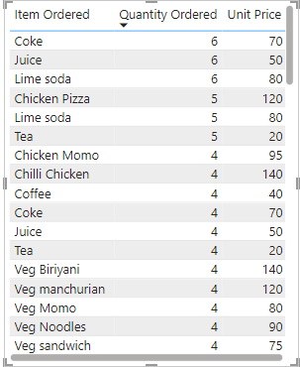

We observe that lower-priced items tend to have more units ordered in a single purchase. Specifically, Coke, Juice, and Lime Soda, priced at 70, 50, and 80 respectively, have each been ordered 6 times in a single order.

**3.Visually present the following in a single view:**

1. **The percentage of sales amount generated for each item in different types of orders; we should be able to filter the order type.**

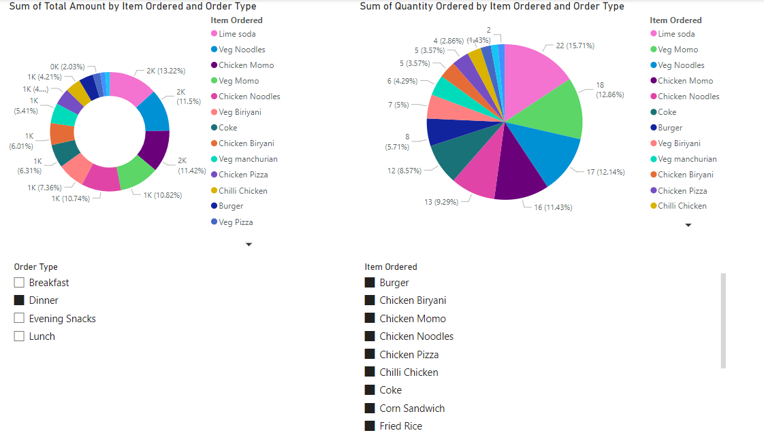

1. **The total quantity ordered for each item in different order types; we should be able to filter the items ordered.**
2. **Identify the 3 top selling items and 3 least selling items in each order type in terms of quantity.**

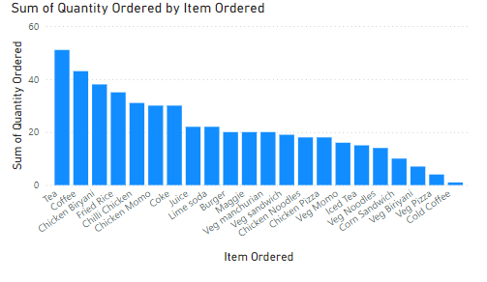

**Top 3 Selling Items:**

1. **Tea**
2. **Coffee**
3. **Chicken Biryani**

**Bottom 3 Selling Items:**

1. **Veg Biryani**
2. **Veg Pizza**
3. **Cold Coffee**
4. **Identify 3 items that are contributing higher to the sale amount and the 3 items that are contributing much less to the sales amount.**

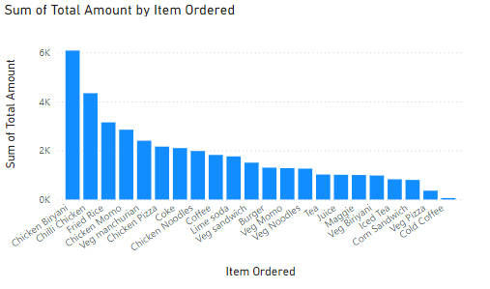

**Top 3 Items Contributing to Sales Amount:**

1. Chicken Biryani
2. Chilli Chicken
3. Fried rice

**Bottom 3 Items Contributing to Sales Amount:**

1. Cold Coffee
2. Veg Pizza
3. Iced Tea

**4.Find out:**

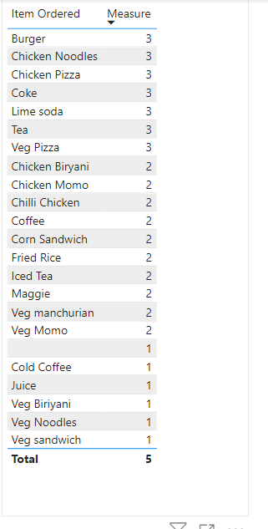

1. **Which are the items being ordered by customers in at least 3 meal types?**

**Items Ordered in at Least 3 Meal Types:**

1. Burger
2. Chicken Noodles
3. Chicken Pizza
4. Coke
5. Lime soda
6. Tea
7. Veg Pizza

**Explanation:**

The "Measure" column in the image represents the number of times an item was ordered. By observing the image, we can see that these 7 items have a measure of 3 or higher, indicating they were ordered by customers in at least 3 meal types.

1. **Which are the items being ordered in more than one meal type?**

**a. Items Ordered in More Than One Meal Type**

Based on the provided data, we can assume that any item with a "Measure" greater than 1 is likely being ordered in more than one meal type. Therefore, all items on the list except for:

* Cold Coffee
* Juice
* Veg Biryani
* Veg Noodles
* Veg Sandwich

are potentially being ordered in more than one meal type.

1. **What insights do we get from this? Should we discontinue any of these items, and why?**

**Insights:**

* **Popular Items:** Items with higher "Measure" values (like Burger, Chicken Noodles, Chicken Pizza, Coke, Lime Soda, Tea, and Veg Pizza) are more popular and versatile.
* **Less Popular Items:** Items with lower "Measure" values might need further analysis to understand their performance.

**Should we discontinue any items?**

Deciding whether to discontinue an item requires more context. Here are some factors to consider:

* **Profitability:** Are these items profitable? If not, discontinuation might be justified.
* **Customer Feedback:** Is there negative feedback about these items?
* **Inventory Management:** Do these items contribute to inventory challenges?
* **Menu Balance:** Does the menu need to be streamlined?

**Based solely on the data provided, it's premature to recommend discontinuing any items.** We would need additional information about factors like profitability, customer preferences, and overall menu strategy.